SIMATS ENGINEERING
ASSESSMENT TOOL 1

COURSE CODE:DSA-0504 COURSE NAME: QUERY PROCESSING FOR DATA SCIENCE

COURSE OUTCOME COVERED

CO1: Identify and clean inconsistencies in data by handling missing values, outliers, formatting issues, and applying techniques

Assessment Tool Weightage: 40%

QUESTIONS: 15 TOTAL MARKS:

Annexure A

APPLICATION BASED QUESTIONS

Code of Conduct:

I SAHASRA V(192424234 )(Name / Reg No) certify that this submission is my original work and that I have adhered to the guidelines specified for this assessment.
I understand that any violation of academic integrity rules will result in disciplinary action.

Signature of the student: SAHASRA V

ANALYSIS  (5 MARKS) | APPLICATIO N  (5 MARKS) | EVALUATION  (5 MARKS) | SYNTHESIS  (5 MARKS) | TOTAL  (20 MARKS)

- Online Shopping Order Processing (10 Marks)
An e-commerce platform stores customer information in a JSON file and order
details in a CSV file. Both datasets share a common Customer ID. Write a Python
program to read the datasets, merge the customer and order information, identify
customers who have placed multiple orders, and generate a consolidated report in
CSV format containing complete customer and order details.
give me a python code I already have dataset just import some queries and give

Aim
To develop a Streamlit dashboard that reads a student admission CSV file, performs data wrangling operations, removes duplicate records, standardizes data, and generates a cleaned dataset for analysis.

Objective
- Read student admission records from a CSV file.
- Clean and standardize the data.
- Remove duplicate records.
- Handle missing phone numbers.
- Display the cleaned data with charts and query results.
- Export the cleaned dataset as a new CSV file.

Description of Algorithm
- Read the admission CSV file using Pandas.
- Remove extra spaces from student names and department names.
- Convert names and department names into proper title case.
- Replace missing phone numbers with "Not Available".
- Remove duplicate records.
- Display the cleaned dataset and summary statistics.

Input
- Input File: admission.csv
- Fields: Student ID, Name, Department, Phone Number (and other admission details if available).
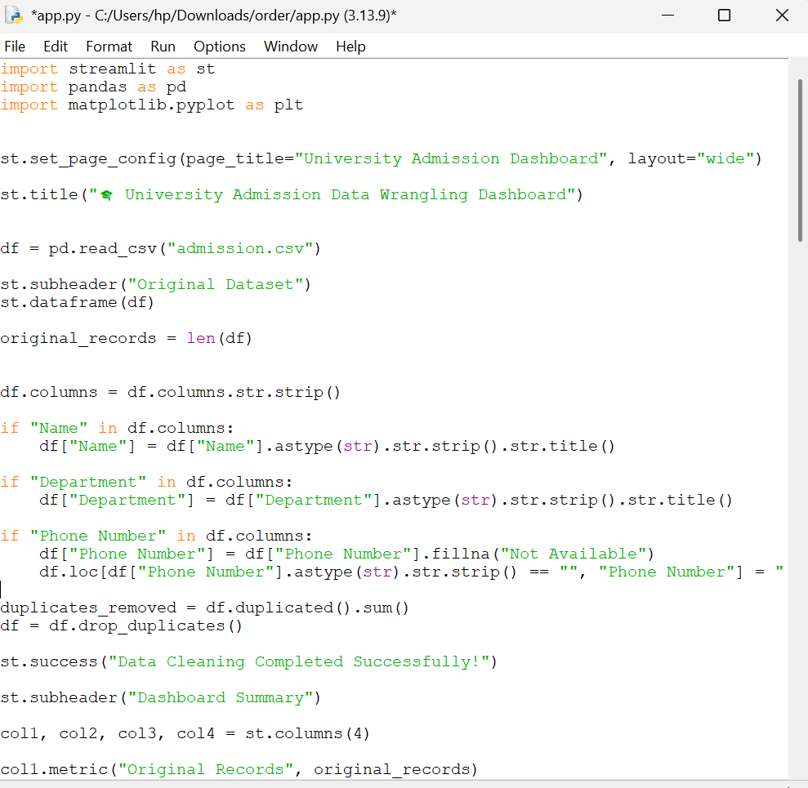

OUTPUT:
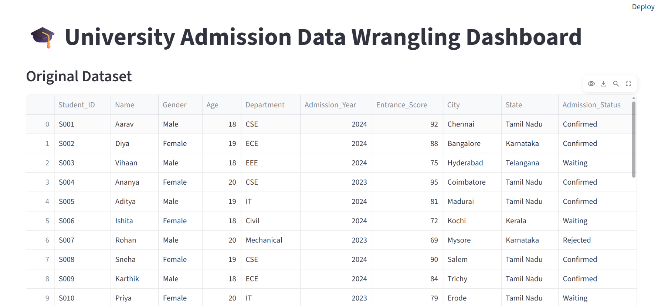

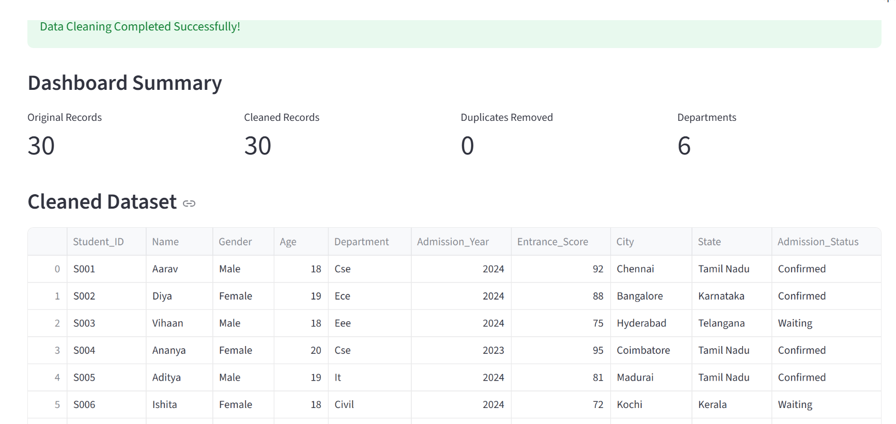

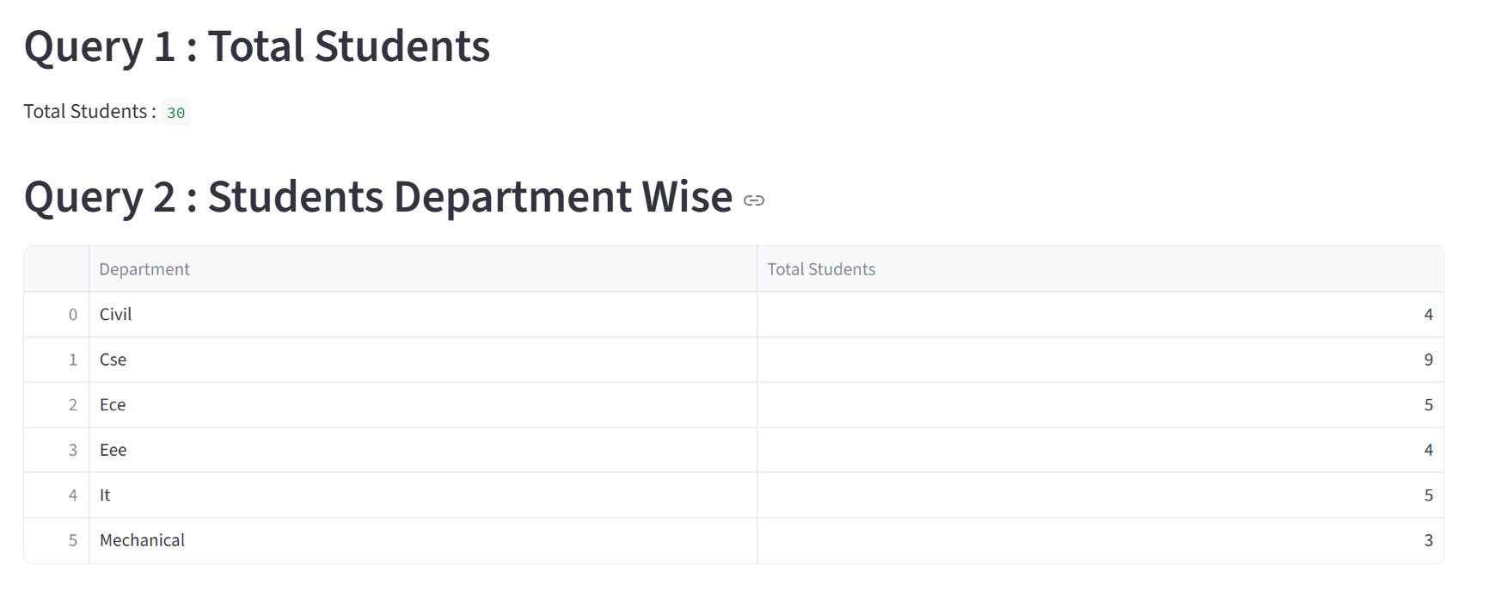

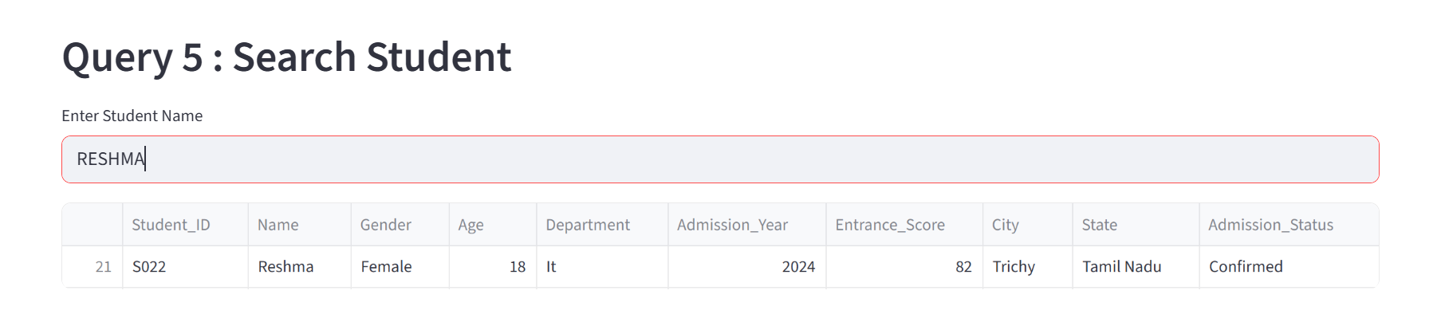

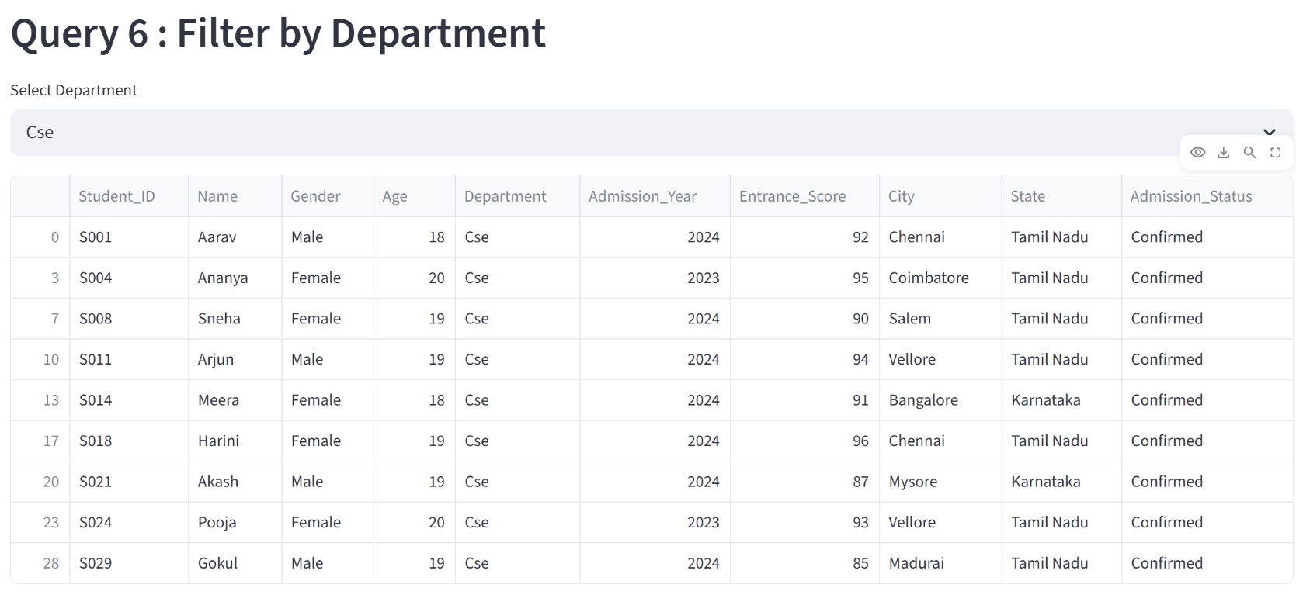

- Hospital Patient Data Validation (10 Marks)
A hospital stores patient information in a CSV file containing patient IDs, names,
ages, blood groups, and contact numbers. Some records contain missing values,
invalid ages, and duplicate patient IDs. Write a Python program to read the
dataset, identify and correct data quality issues, remove duplicate records, and
generate a validated dataset that can be imported into the hospital database.

Aim
To develop a Streamlit-based Hospital Patient Data Validation System that reads patient records from a CSV file, validates the data, removes duplicate patient IDs, corrects invalid entries, and generates a validated dataset for hospital database management.

Objective
- Read patient records from a CSV file.
- Validate patient details such as age, blood group, and contact number.
- Remove duplicate patient IDs.
- Correct invalid or missing values.
- Display patient information through an interactive dashboard.
- Export the validated dataset as a new CSV file.

Description of Algorithm
- Read the patient dataset from patient.csv using Pandas.
- Remove extra spaces and standardize patient names and blood groups.
- Validate patient ages and replace invalid values with the median age.
- Fill missing contact numbers with "Not Available".
- Remove duplicate patient IDs.

Input
- Input File: patient.csv
- Fields: Patient ID, Patient Name, Age, Blood Group, Contact Number.
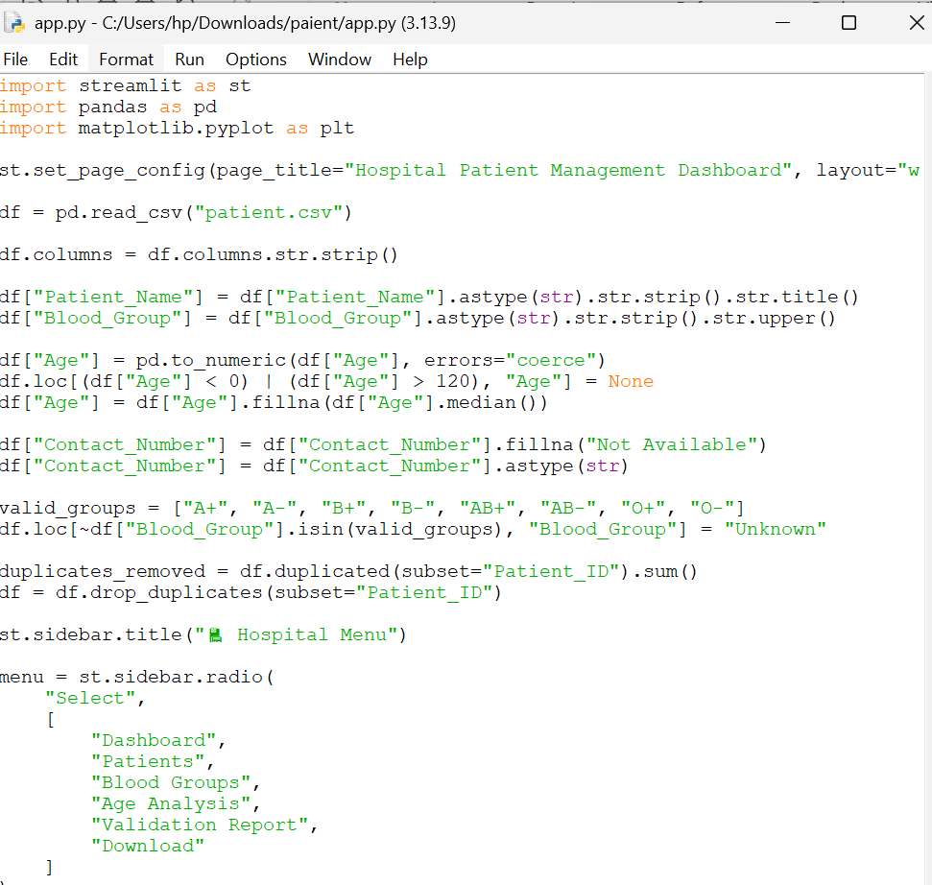

OUTPUT:

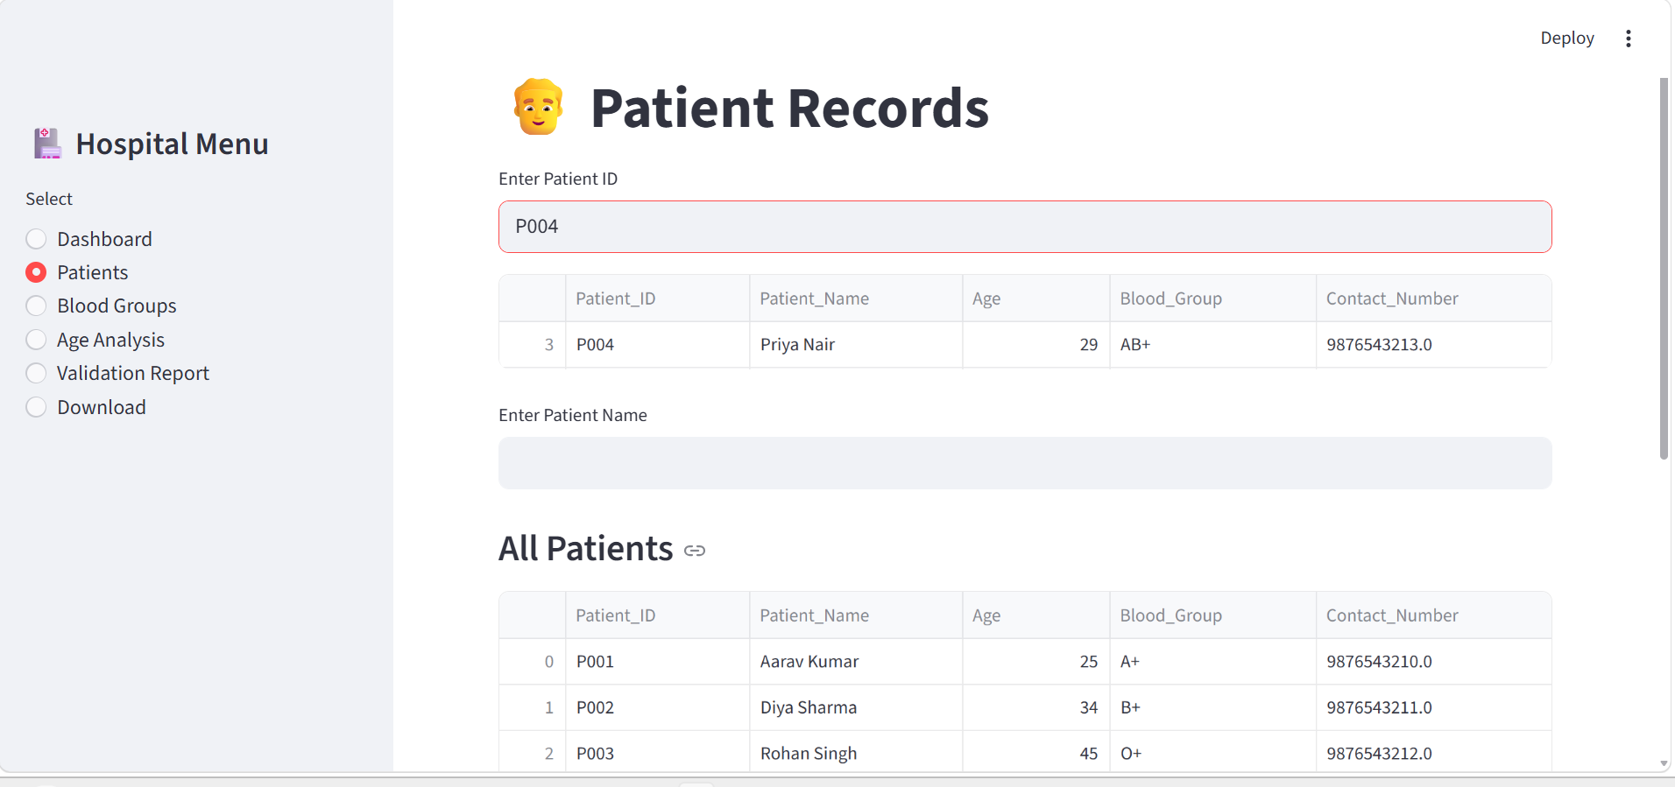

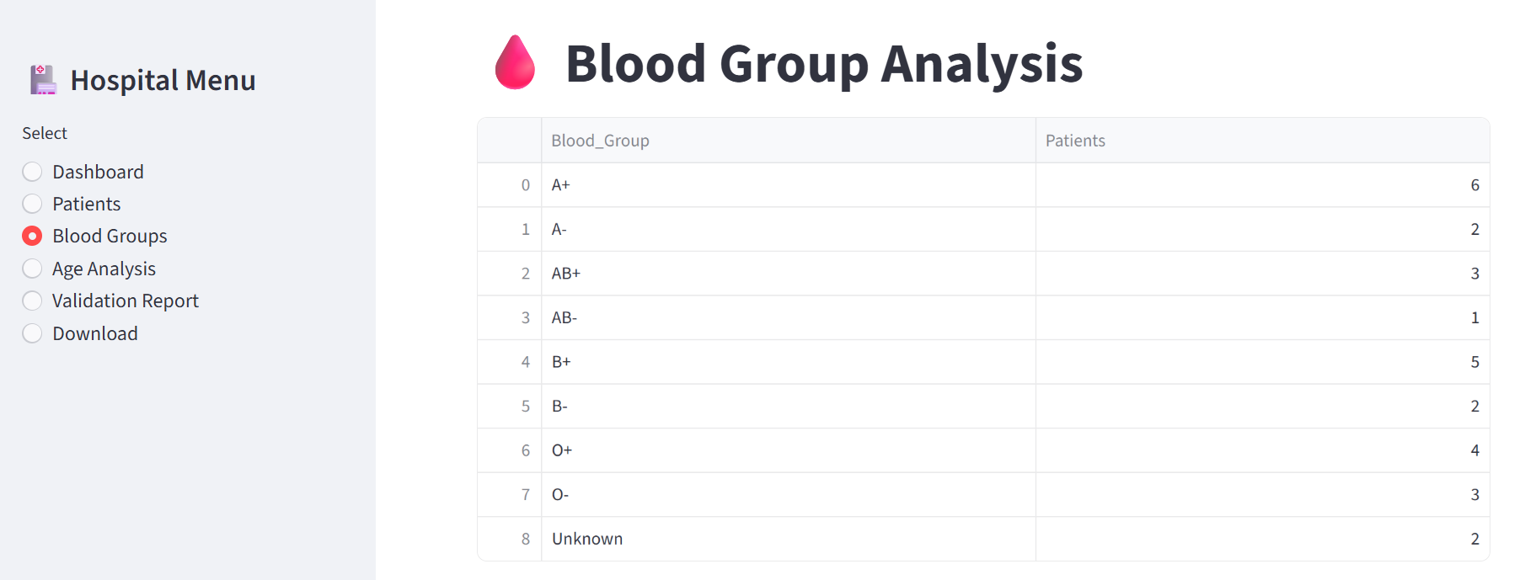

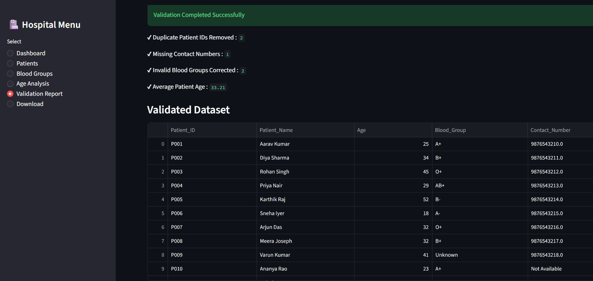

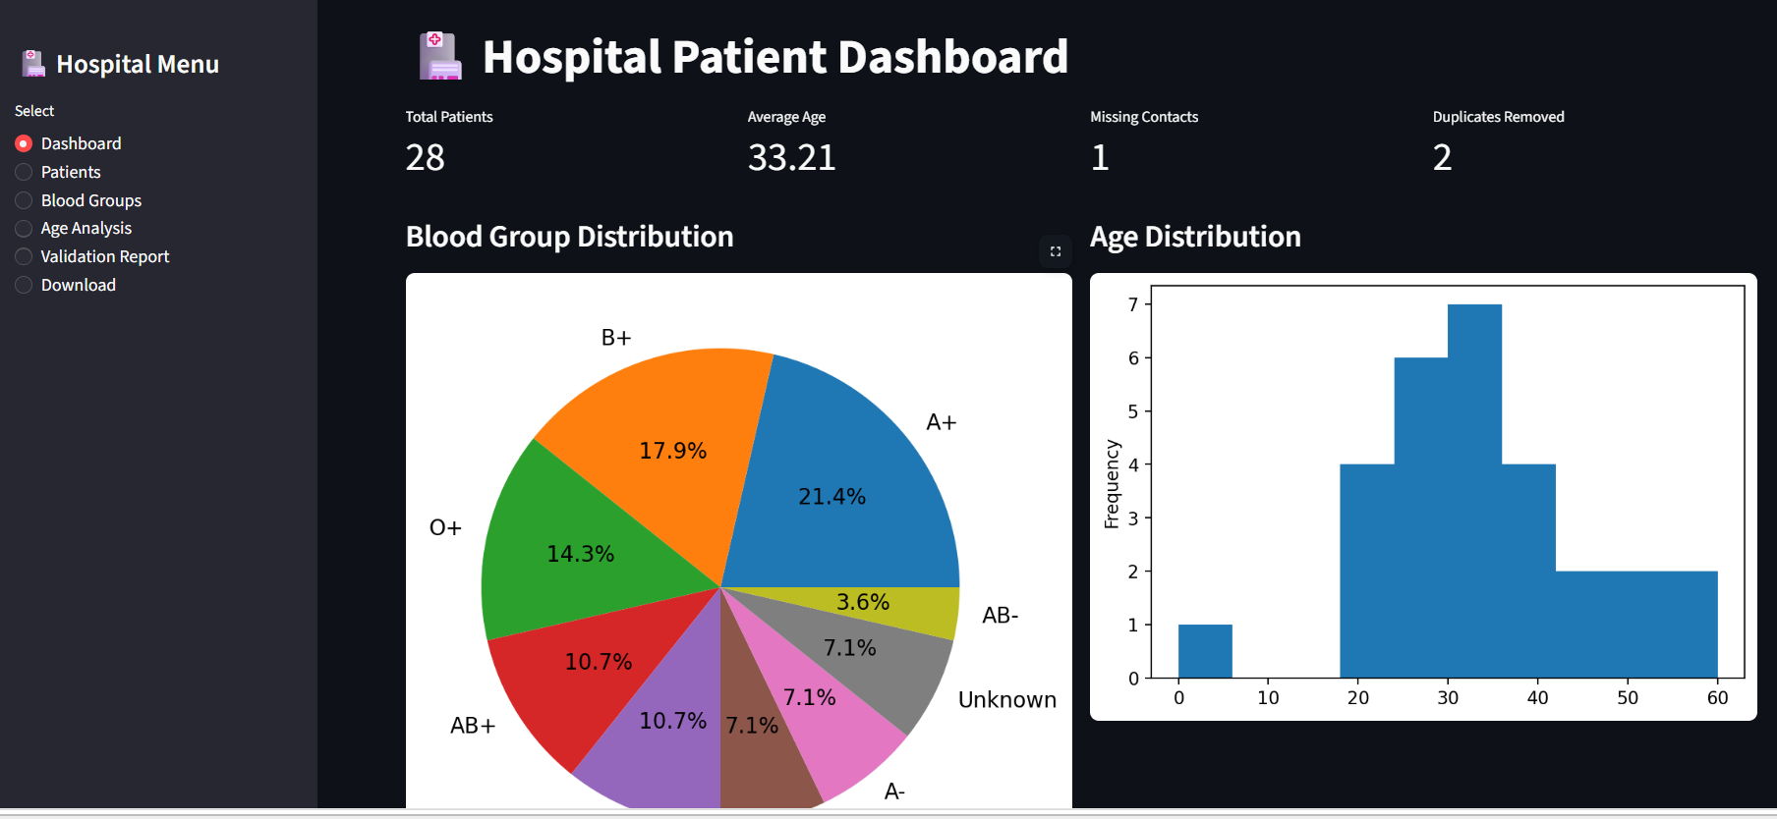

Banking Transaction Analysis (10 Marks)

A bank receives daily transaction details in CSV format from different branches.The dataset contains duplicate transaction IDs, blank account numbers, and inconsistent transaction types. Write a Python program to import the CSV file,perform data wrangling operations to clean and standardize the records, identify invalid transactions, and save the processed data into a new file for further financial analysis.

Aim
To develop a Streamlit-based Banking Transaction Analysis System that reads transaction records from a CSV file, performs data wrangling operations to clean and standardize the data, identifies invalid transactions, removes duplicate transaction IDs, and generates a processed dataset for financial analysis.

Objective
- Import banking transaction data from a CSV file.
- Remove duplicate transaction IDs.
- Handle blank account numbers.
- Standardize transaction types (Credit/Debit).

Description of Algorithm
- Read the transaction dataset from bank.csv using Pandas.
- Remove extra spaces from the column values.
- Fill blank account numbers with "Not Available".
- Standardize transaction types (e.g., CR, Credit → Credit and DR, Debit → Debit).
- Identify invalid transaction types.

Input
- Input File: bank.csv
- Input :Transaction_ID,Account_Number,Customer_Name,Transaction_Type

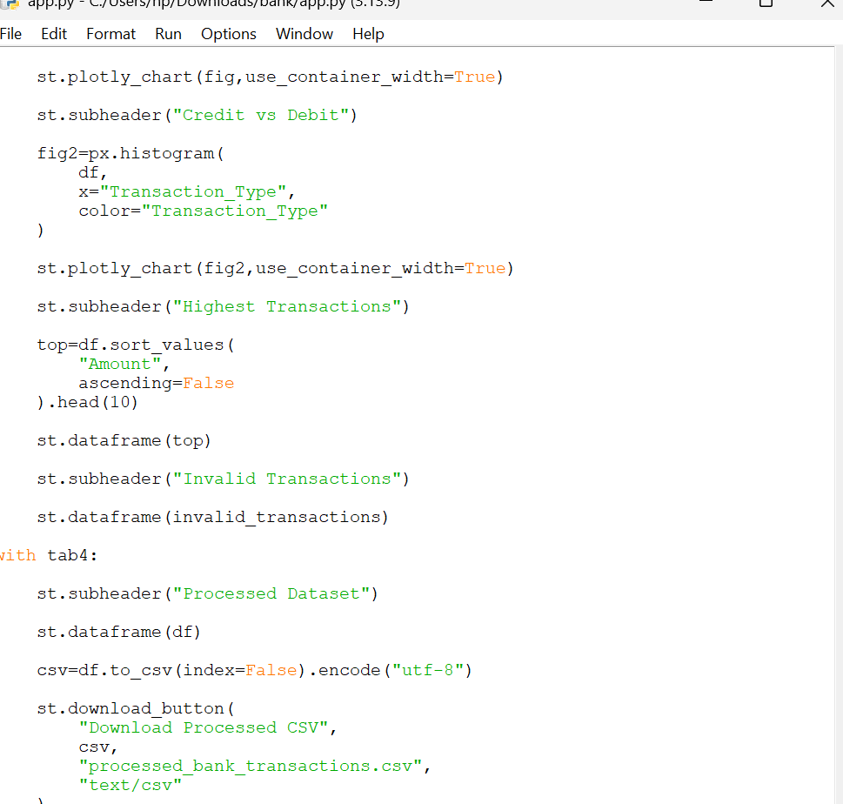

OUTPUT:

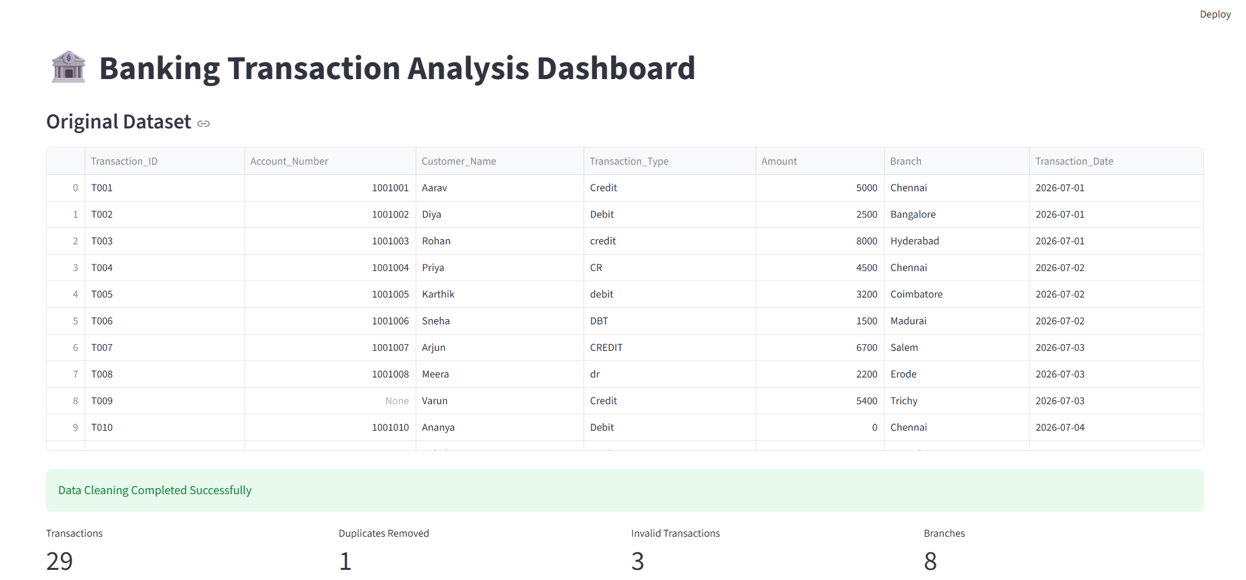

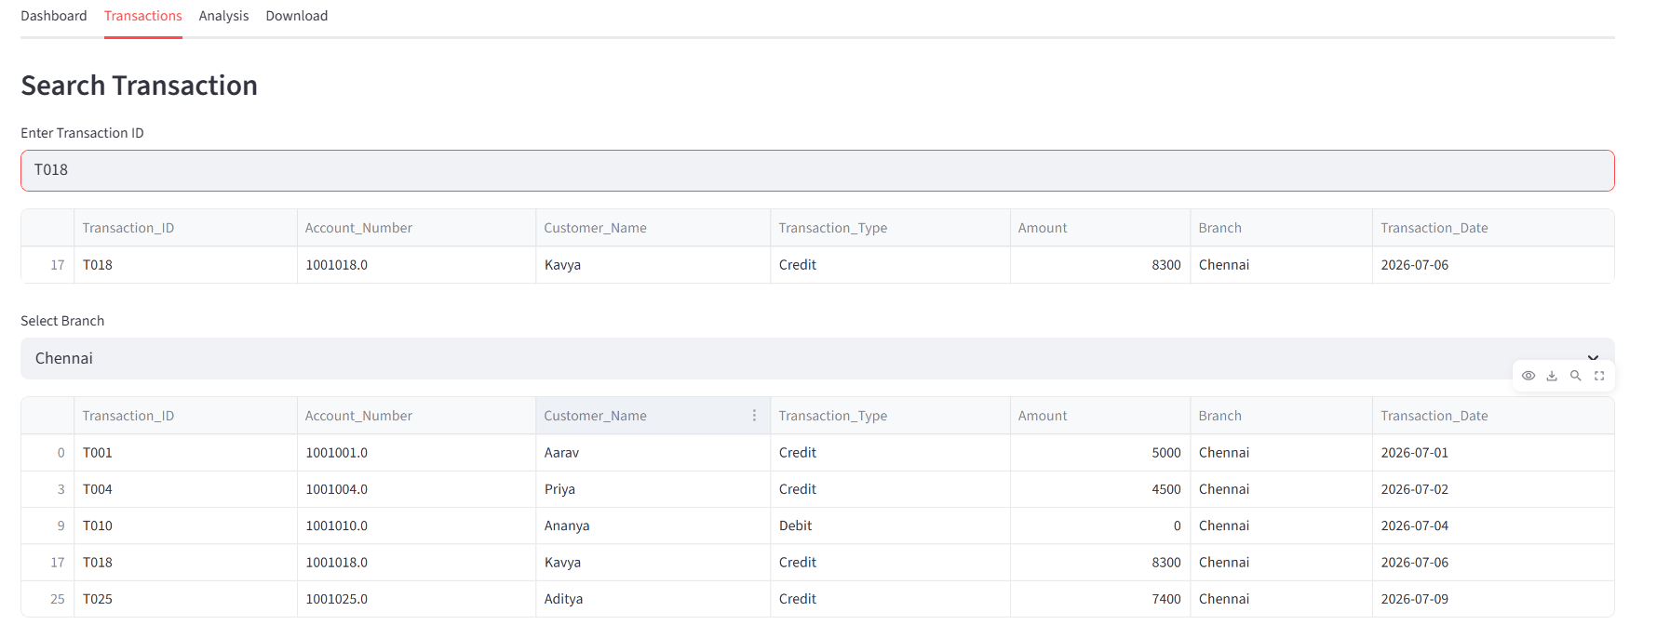

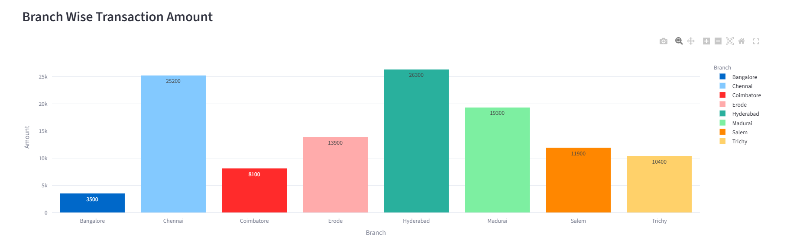

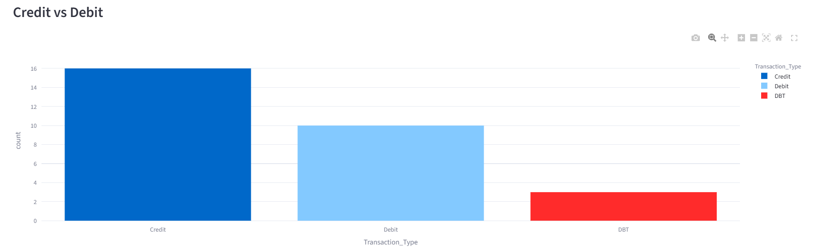

- College Attendance Management (10 Marks) A college maintains daily attendance records in a CSV file. The file contains duplicate attendance entries, missing roll numbers, and inconsistent date formats. Write a Python program to read the file, clean the dataset, remove duplicate records, standardize the dates,

Aim
To develop a Python program that reads a college attendance CSV file, detects and corrects data quality issues such as duplicate records, missing roll numbers, and inconsistent date formats, and generates a cleaned attendance dataset.

Objective
- To import attendance data from a CSV file.
- To identify and remove duplicate attendance records.
- To detect missing roll numbers.
- To standardize different date formats into a single format (YYYY-MM-DD).
- To generate a cleaned CSV file for further academic use.

Description of Algorithm
- Start the program.
- Import the required Python libraries (pandas).
- Read the attendance CSV file into a DataFrame.
- Identify duplicate attendance records and remove them.
- Check for missing roll numbers and mark or remove those records.

INPUT:
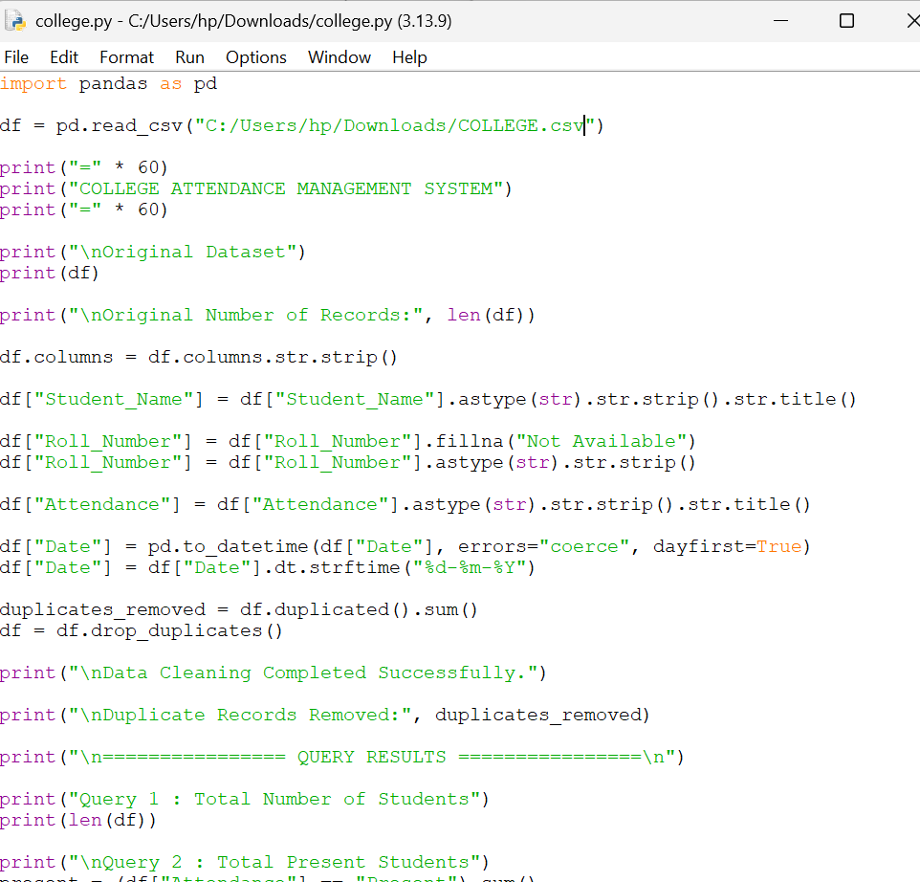

OUTPUT:
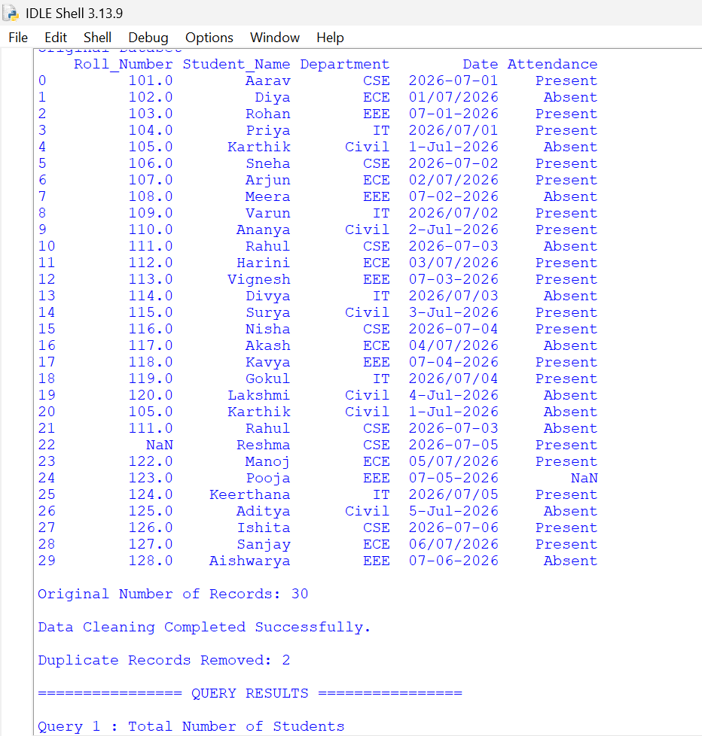

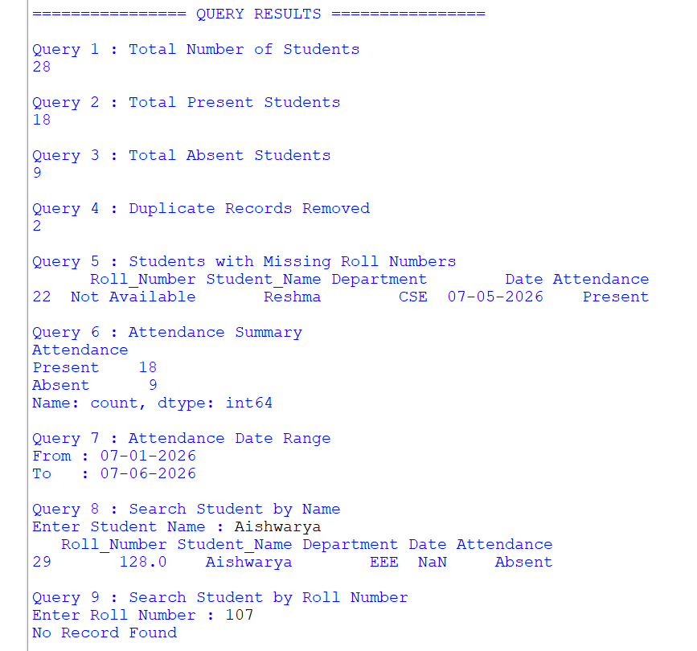

- University Course Information Management (10 Marks)
A university maintains course details in an XML file and faculty information in a
CSV file. The Course ID is common to both datasets. Write a Python program to
parse the XML file, read the CSV file, integrate the two datasets, identify courses
without assigned faculty members, and generate a structured output suitable for
updating the university&#39;s academic database.

Aim
To develop a Python program that parses course information from an XML file, reads faculty information from a CSV file, integrates both datasets using the common Course_ID, identifies courses without assigned faculty members, and generates a consolidated report for updating the university academic database.

Objective
- To read course details from an XML file.
- To read faculty details from a CSV file.
- To integrate both datasets using Course_ID.
- To identify courses that do not have assigned faculty members.
- To generate a structured output in CSV format for academic database updates.

Description of Algorithm
- Start the program.
- Import the required libraries (pandas and xml.etree.ElementTree).
- Parse the XML file and extract course details.
- Store the extracted course data in a DataFrame.
- Read the faculty details from the CSV file into another DataFrame.

Input
- courses.xml (Course Details)
- faculty.csv (Faculty Details)

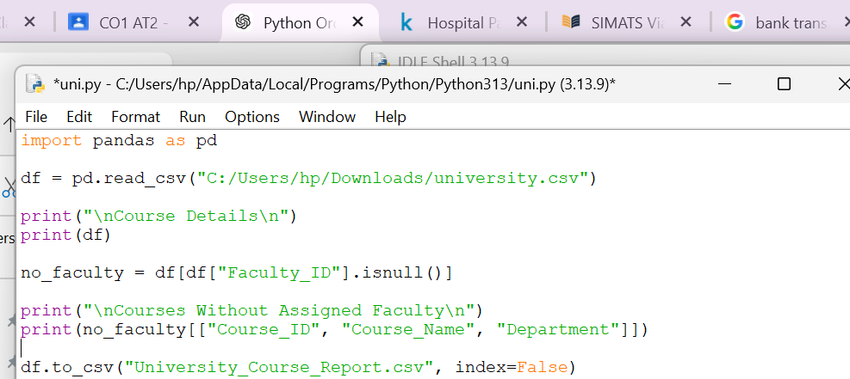

Output:
